Writing for Understanding: The Protestant Reformation

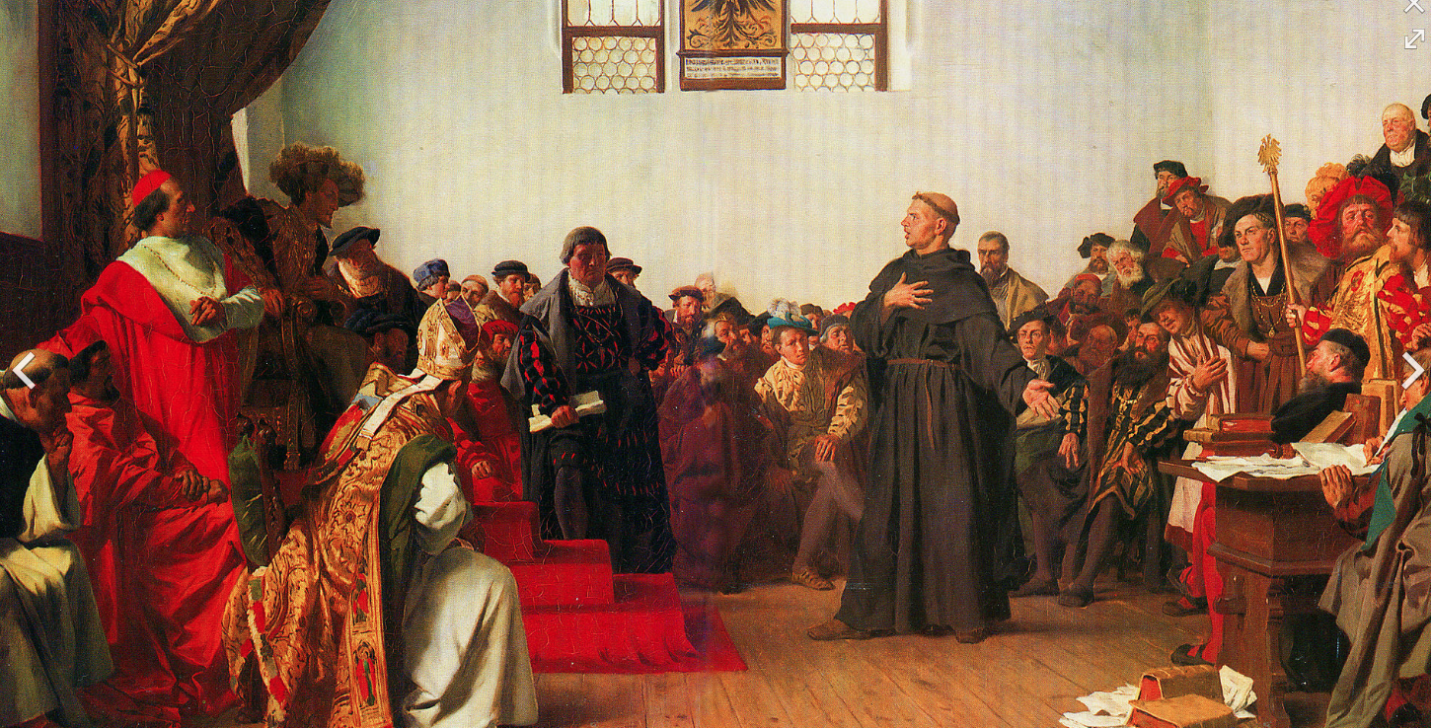

"Unless I am convinced by the testimony of the Scriptures or by clear reason (for I do not trust either in the pope or in councils alone, since it is well known that they have often erred and contradicted themselves), I am bound by the Scriptures I have quoted and my conscience is captive to the Word of God. I cannot and will not recant anything, since it is neither safe nor right to go against conscience. May God help me.Amen." Martin Luther, 1521.

In many ways the new "humanism" of the Renaissance provided the conditions for the most dramatic crisis in Western Christianity. For more than one thousand years, the Roman Catholic Church dominated the religious, economic, and political spheres throughout Europe.

Two of the major figures of the Protestant Reformation (1517 to 1648 AD) were the theologians Martin Luther and John Calvin. Their denunciation of certain practices and teachings of the Roman Catholic Church had far-reaching consequences.

After reading about the Protestant Reformation, please describe the major views of Martin Luther and John Calvin. How did Johann Tetzel provoke Luther?

Hints: be sure you can answer the following before you begin.

Explain "humanism" as it relates to the intellectual climate of the 1500's.

Describe the major influence of the Roman Church prior to this time.

What invention(s) caused the ideas of the Protestant reformers to reach a vast audience?

What action caused did the Reformation become such a big crisis in the Church? What were some of the main beliefs of Martin Luther?

Assignment

Pretend that you are active in the social and political life of Mainz, Germany at the time when Martin Luther was making his views known there. Write a detailed personal letter to your sisters describing what you witness and know. Pretend to give his shocking ideas a "fair hearing" as you express your reaction.

Be sure to structure your letter to be at least six paragraphs in length, using all the conventions of good English. Focus on specific factual evidence from the documents.

Your purpose is to reveal to the reader as much information as you know about Martin Luther's role in the start of the Protestant Reformation.

