APPENDIX #3 - Maritime Trade in Southeast Asia

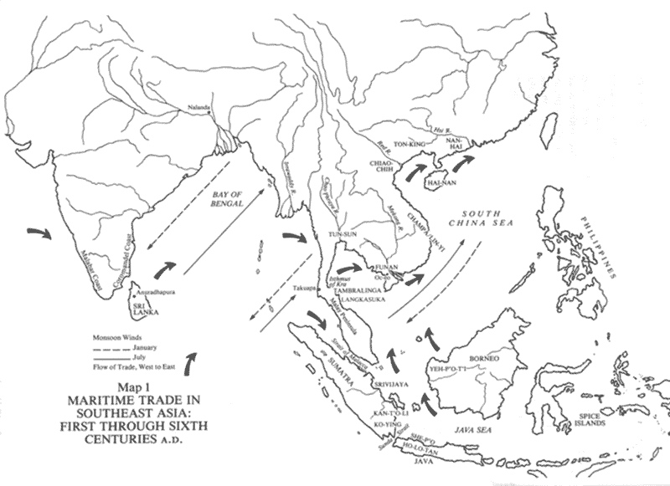

Maritime Trade in Southeast Asia - Monsoon Winds Map
Southeast Asian Trading Systems (from Kenneth R. Hall. Maritime Trade and State Development in Early South East Asia, University of Hawaii Press, Honolulu, 1985,
http://humanities.cqu.edu.au/history/52148/maps/maritime_trade.html

