APPENDIX #1 - Examples of Cham Art
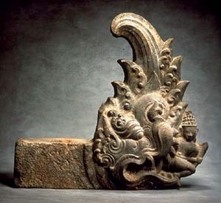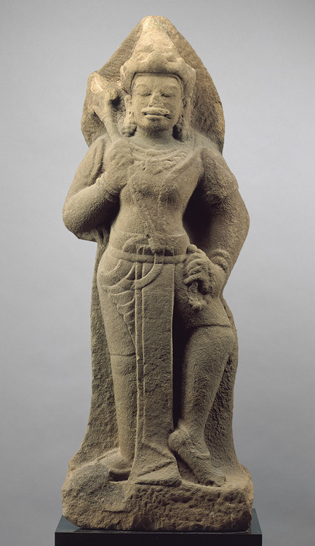
Mythical Creature Shiva
Courtesy of the Courtesy of the
Asian Art Museum, San Francisco Metropolitan Museum of Art

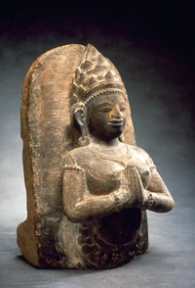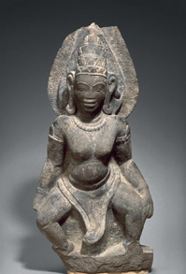
Worshipping Celestial Standing Female Figure

(Both images courtesy of The Asian Art Museum, San Francisco, CA

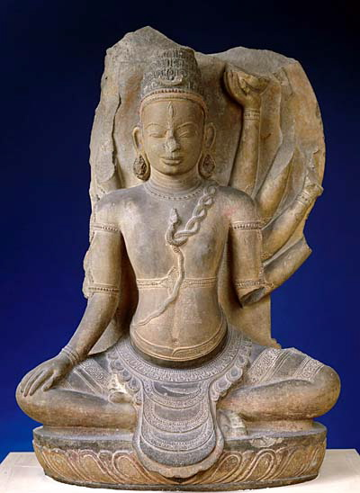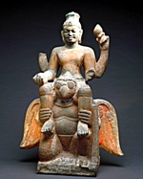
Shiva with cobra Vishnu astride Garuda

Both images courtesy of Guimet National Museum of Asian Art, Paris.

Sculptures at Cham Museum, Da Nang, Vietnam

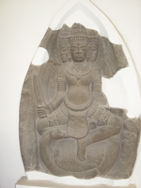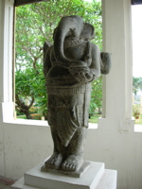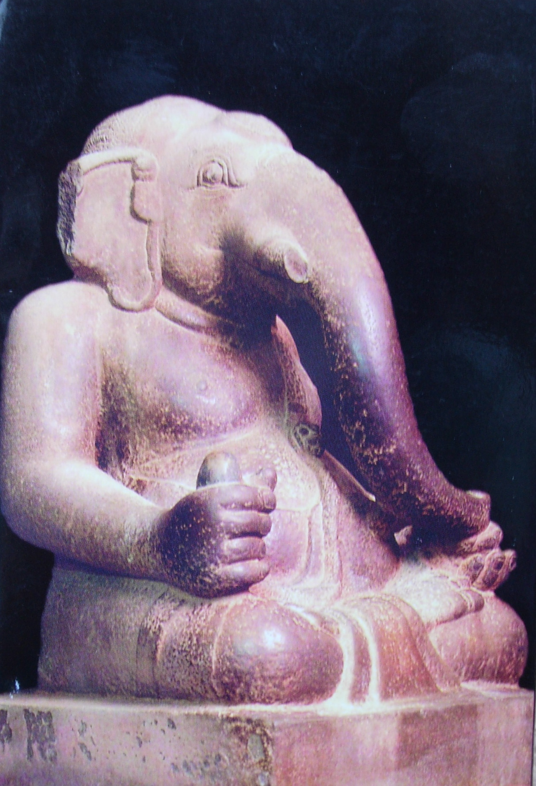
Brahma Standing Ganesh Seated Ganesh

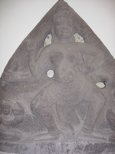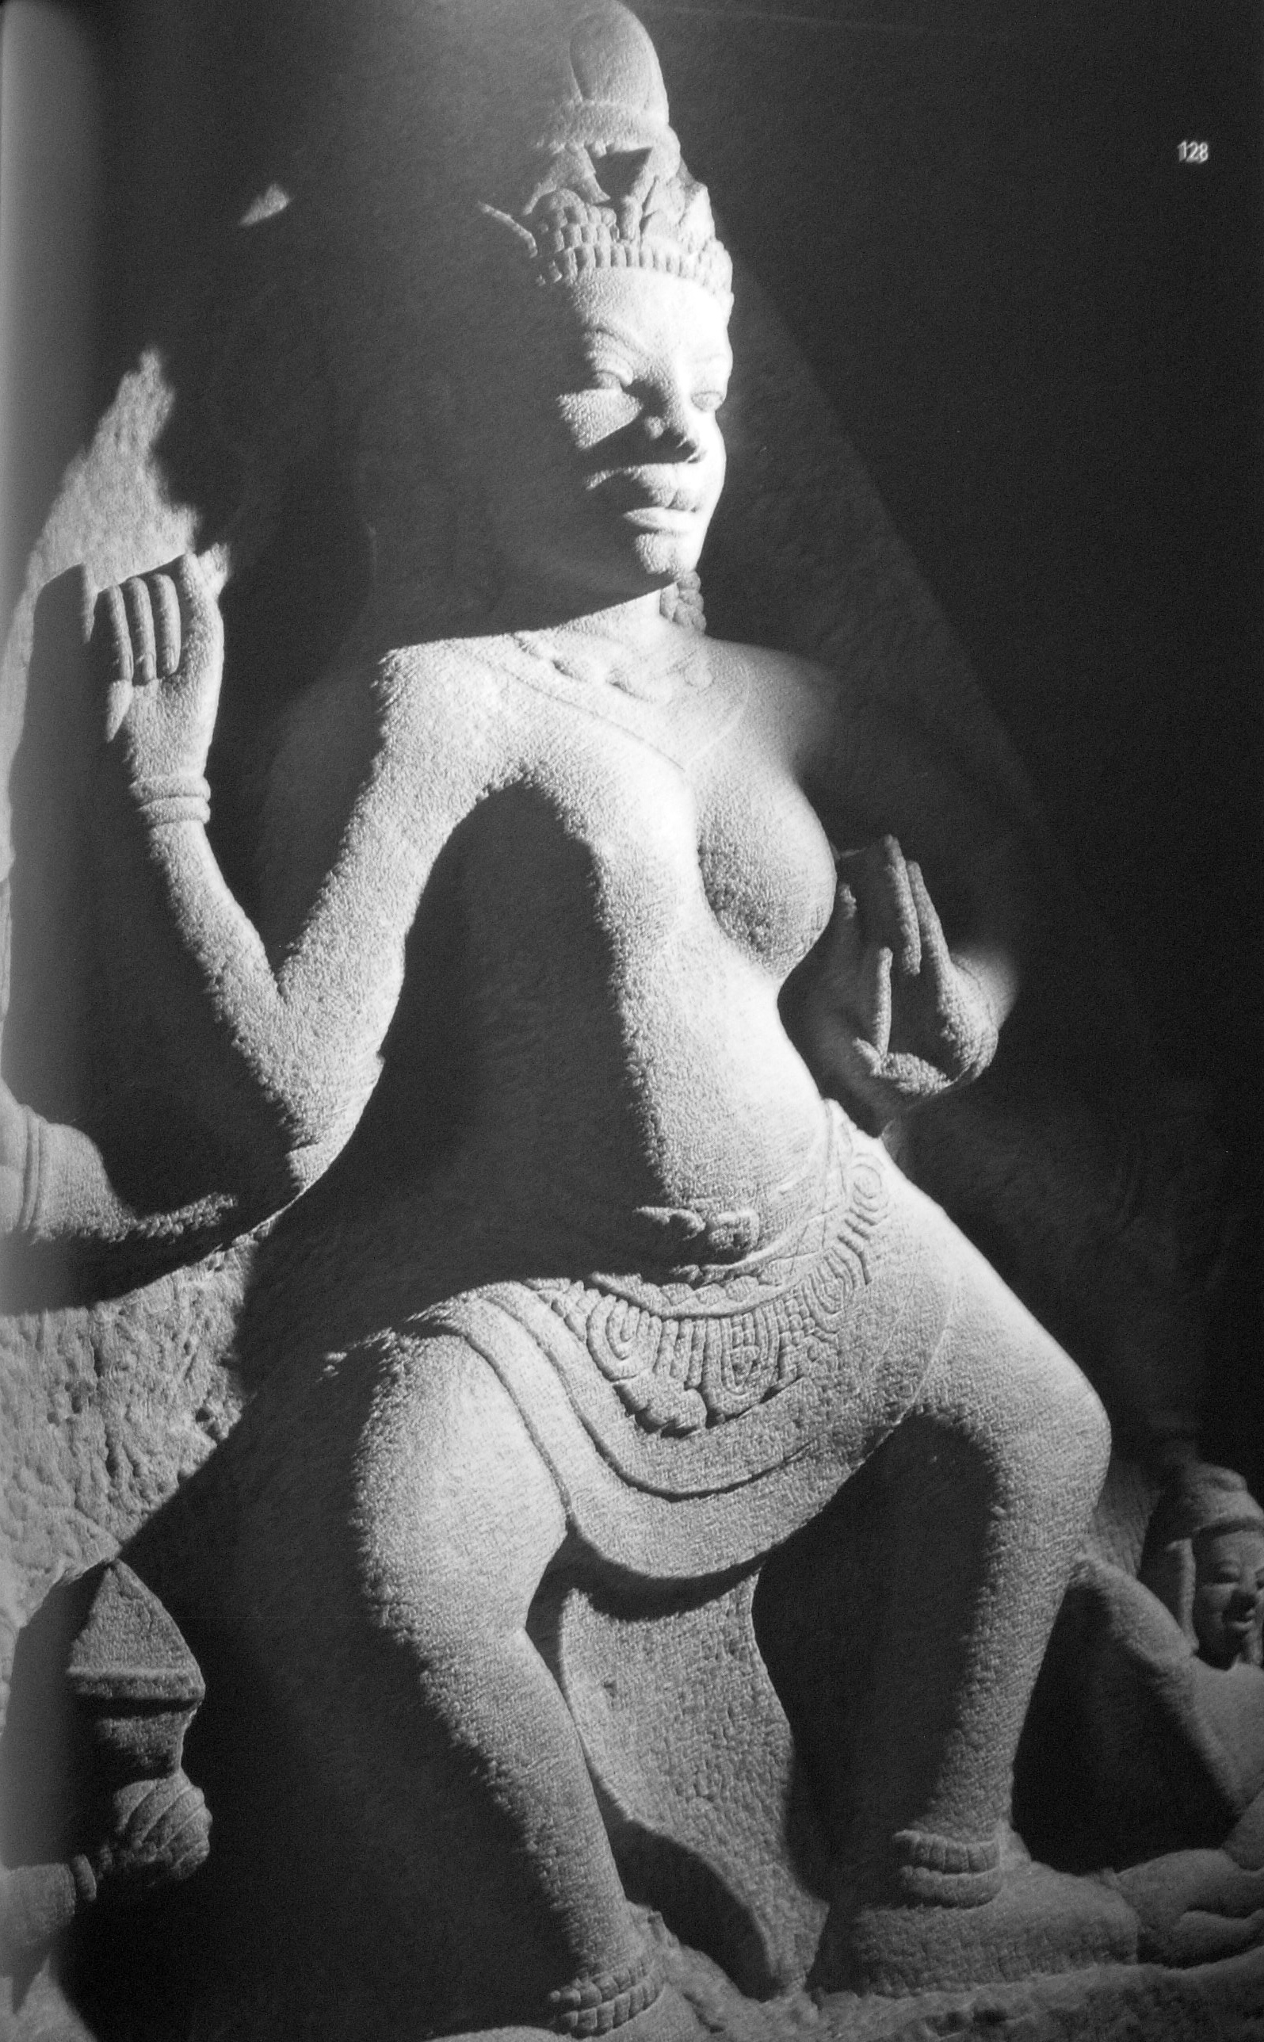
Parvati Parvati

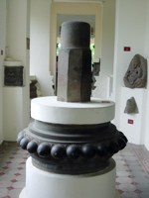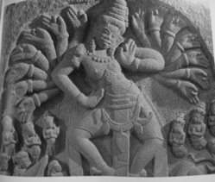
Shiva linga on uroja pedestal Dancing Shiva

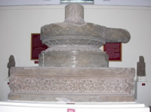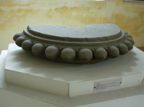
Tra Kieu pedestal Pedestal with uroja
(scenes of Ramayana around the base)
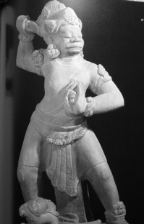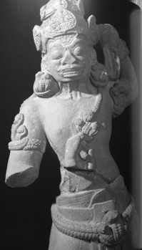
Dvarapala Dvarapala

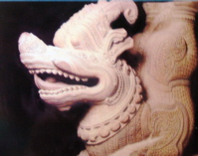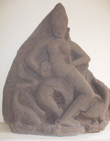
Makara, a sea monster Saraswati

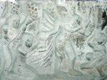
Shiva with 28 arms

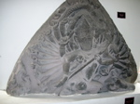

Ravana

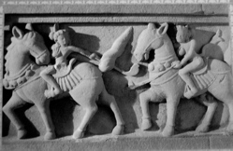
Polo Players on horses
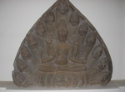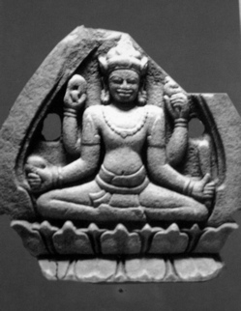
Two images of Vishnu

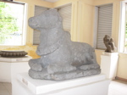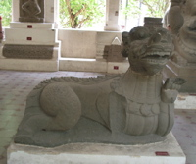

Nandi, the vehicle of Shiva Makara, a sea monster

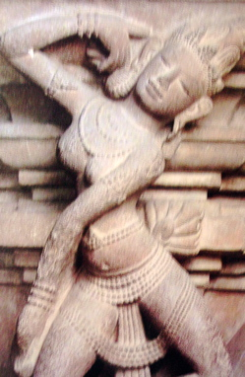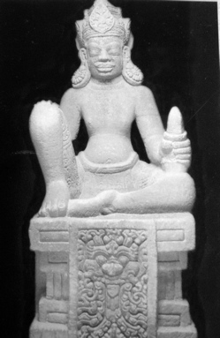
Tra Kieu Apsara Dharmapala

Bas relief in the outer gallery at Bayon in Angkor

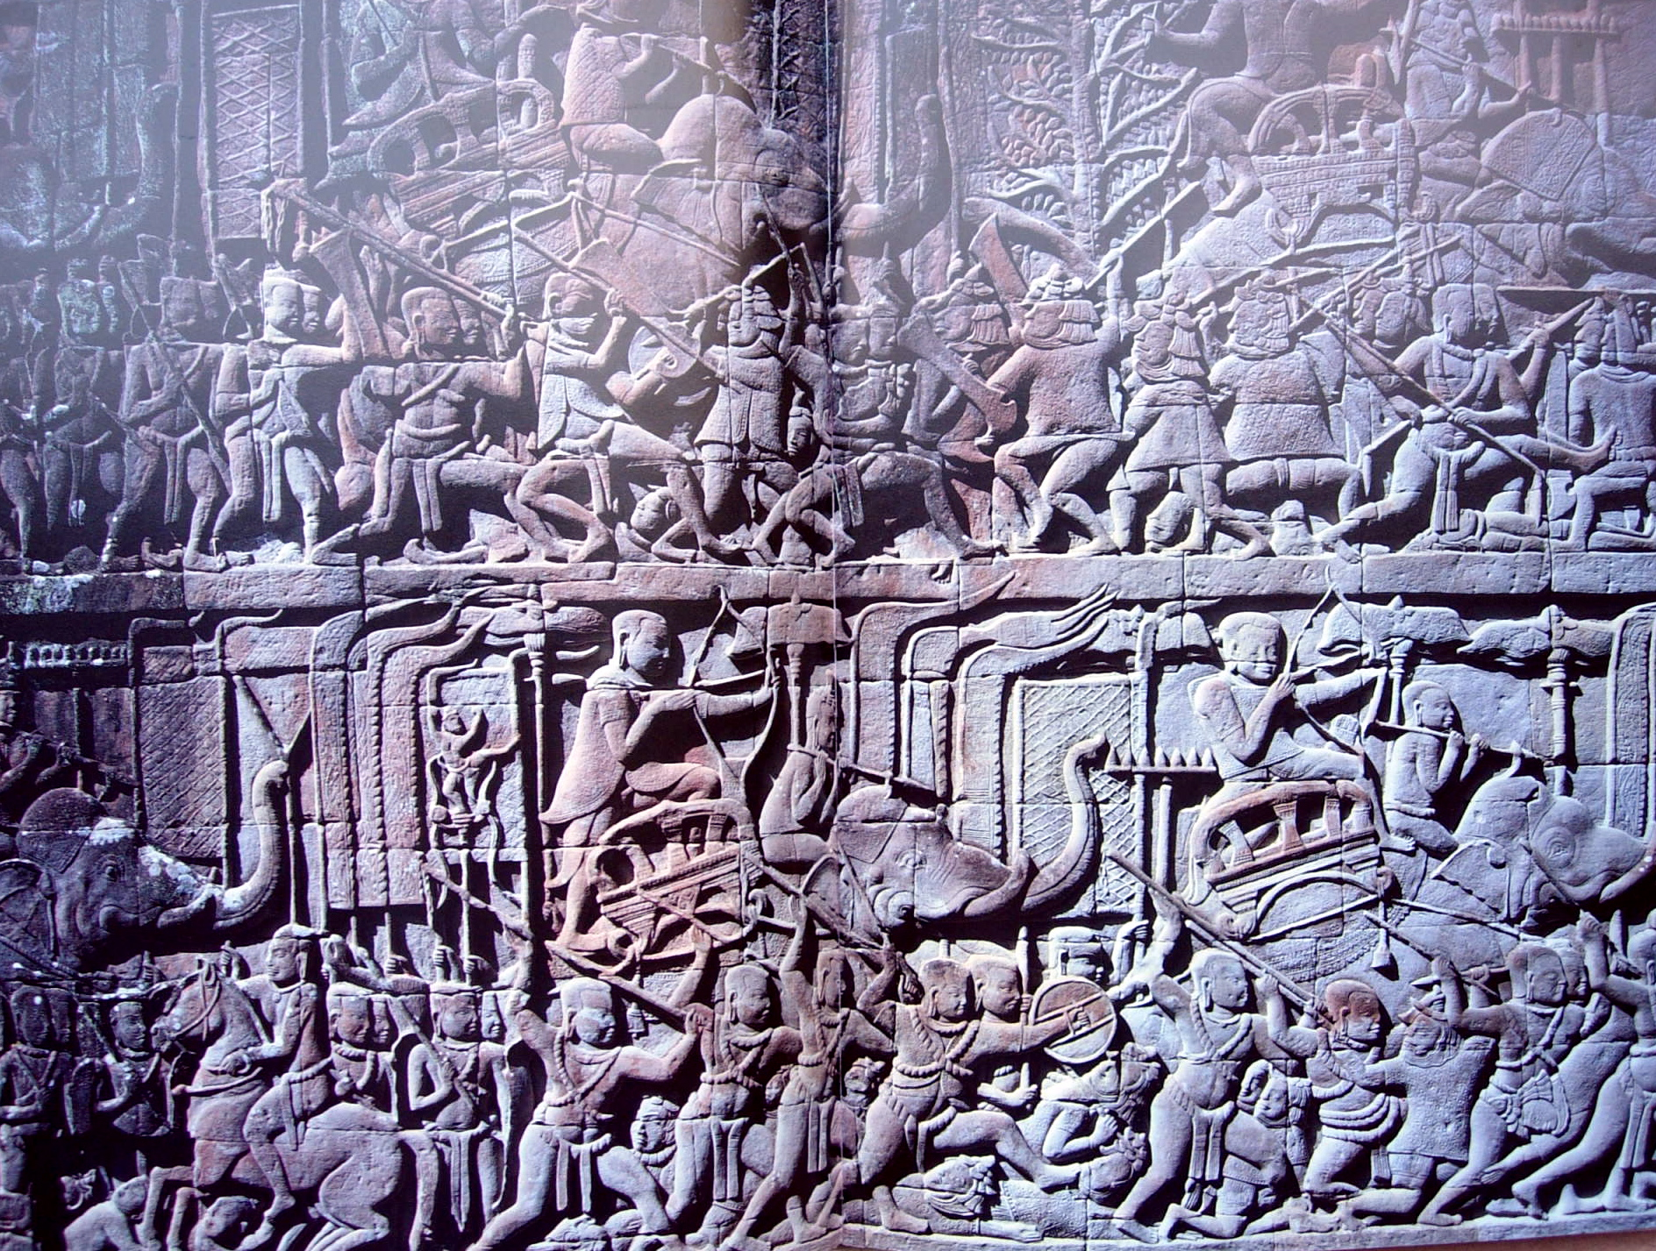

The epic struggle between the devas and the asuras in the “Churning in the Ocean of Milk” is a prominent image at Angkor Wat. Early scholars suggested that this represented real historical battles between the Khmer and the Cham. However, Jean Boisselier argues that contemporary events of the time were equated with scenes from ancient history and mythology. The Khmer king, Jayavarman VII, may have commemorated his defeat of the Cham by associating himself with Indra, king of the gods.

