Oral Traditions:
The Art of Storytelling

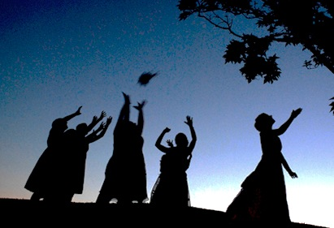

Thousands of years ago, families would gather around the fire at night to listen to their elders or traveling bards tell stories. Spoken word, chanting, and pantomime helped to inform and educate the earliest people and connect themselves to their own culture. All cultures uses oral narratives to teach religious, social, and political values and ideals.

In this short unit, you will recreate and enact one Origin Story to teach your classmates. More importantly, you will need to incorporate "the art" of storytelling to make the content come to life. Each group will divide their story into Introduction, Beginning, Middle, and End. Every student will be the storyteller for their section using voice, pacing, expression, sound effects, and audience interaction. Please do not bring costumes or props.

Here are some basic guidelines for this challenge:

• Students will need to work in collaborative groups.

• Your group will be given one Origin Story to perform.

• Each member of the group will be responsible for playing a character or
retelling one section of the story.

• Each student will memorize one small part (intro, beginning, middle, or end).

• Assessment will be based on the 5-point rubric (see reverse).

• The Origin Story will be evaluated on Tuesday, September 11th.

