Insert your heading here
Be sure to remove these words!

"The Epic of Gilgamesh"
Reading the epic with the eyes of a historian:

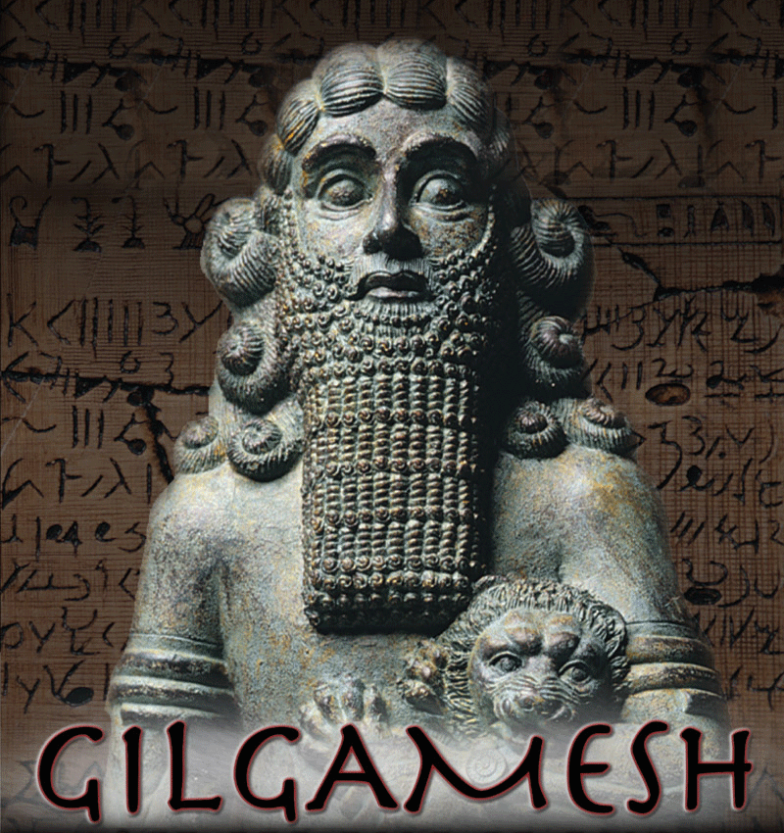

(When we have finished reading the story, insert your favorite quote here.)

Use this table to record three sentences from each chapter that tell historians what life was like in ancient Mesopotamia. FOCUS ON THE CULTURE -- not the story line. Be sure to copy the words as written in the book for each selection.

In the right column, write what this tells us.

"The Epic of Gilgamesh"

Evidence | What does this reveal?
Chapter One:

