APPENDIX #4 - My Son Sanctuary (B complex)
Sanskrit inscriptions found at My son indicate it was probably established in the 4th century as a religious center.

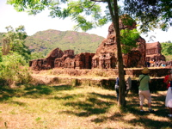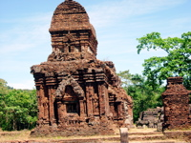

Fired brick temples at B complex at MySon. This sacred site was dedicated to Shiva.
Archaeologists believe it lacks an overall plan, indicating subsequent construction from the 4th through 8th centuries.
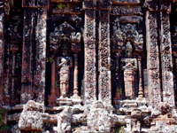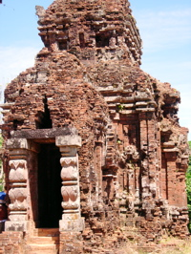

Tall niches house stylized sculptural figures. The entrance has powerful balusters; distinctive vertical lines are balanced by stately kalan.

Other major Cham sites include My Son, Pho Hai, Pho Dam, Khuong My and Dong Duong which was devastated during the Vietnam War.

My Son was declared a World Heritage Site by UNESCO in 1999. Read more at:
UNESCO World Heritage Center:
http://whc.unesco.org/en/list/949 and
http://www.world-heritage-tour.org/asia/vn/mySon/map.html

