APPENDIX #2 - Trade and Exchange in Southeast Asia

From early times Southeast Asia has been a center of trade. Goods from the region, such as gold and spices, and commodities from countries such as China, India, Persia, Greece and Rome were exchanged along land and sea routes.
Metals, ivory, rice, and fine woods were among the products the world wanted from Southeast Asia. Certain rare and exotic goods were particularly in demand in China, Korea, and Japan, among them:
Stingray skins for decorating containers and weapons
Rhinoceros horns for ornaments and medicines
Snake skins to cover the sound boxes of musical instruments

From the 1400s to the 1600s, ceramics from Vietnam and Thailand occupied a major place in Southeast Asian trade. High-quality ceramics were in great demand in Indonesia and the Philippines. Recently discovered shipwrecks in the region reveal the significant role of ceramic trading in Southeast Asia during this period. (Ceramics from such shipwrecks are on view in the second-floor loggia).
From the 1500s onward, European traders, first from Portugal and Spain, and later from Holland and England, traveled to Southeast Asia in search of the pepper, cloves, and nutmeg of the "Spice Islands" (Malukka in Indonesia). Returning with cargoes of hundreds of tons of spices, they earned huge profits.
Though Southeast Asia was a prominent exporter of silk and cotton fibers, the Southeast Asians themselves were great consumers of Chinese silk and Indian cotton textiles. Considered luxury products, these were purchased by the elite as indications of wealth and status.

Asian Art Museum:
http://www.aamdocents.org/AAM/SEA/SEA3.htm#transition

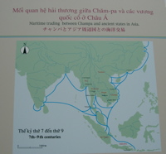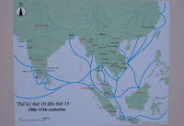

Cham Trade (7th-9th Centuries) Cham Trade (11th - 15th Centuries)
Museum of Trade Ceramics, Hoi An, Vietnam

